READY TO READ SONG LIST - OCTOBER
HOO! from Round Rock Public Library
(Tune: Farmer in the Dell)
The owl goes hoo, (cup hands to mouth)
The owl goes hoo,
Hi ho on Halloween, the owl goes hoo.
Other verses:
The ghost goes boo (wave hands out in front)
The bats go eek (flap arms)
The pumpkin rolls around (roll hands)
The scarecrow waves good-bye (wave)

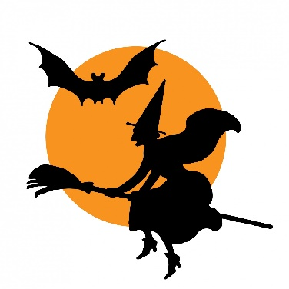
Three Little Witches…(Use fingers for numbers)
One little, Two little, Three little witches,
Fly over haystacks, fly over ditches,
Slid down moonbeams without any hitches,
Hay Ho Halloween's here.

Halloween Night…
(Tune: Frere Jacques)
Jack-o-lanterns, jack-o-lanterns,
Hall-o-ween, Hall-o-ween!
See the owls gliding,
Coal black cats are hiding,
Ghosts go "Boo," ghosts go "Boo!"

